Chapter 3: Energy

3.7 Science as a human endeavour: Solar cells transform the Sun’s light energy into electrical energy

Ask a scientist worksheet answers (pages 54–55)

Dr Niraj Lal - physicist

1 What kinds of things are physicists currently working on? Niraj names many. How many can you remember? Once you have created a list, share it with the person next to you and add in any that you didn’t have.

• How and why the universe is expanding

• How matter works in galaxies

• How matters works on the surface of the Earth

• The forces that are involved with how different bits of matter interact with each other

• How atoms work

• What an atom looks like on the inside, and all the parts of the atom

• How light interact with matters

• How rainbows work

• How to make solar panels more efficient

• How to make new lasers

• Light bulbs and different types of more efficient lights

2 Create a flow diagram (with three stages) showing the energy transformations that take place from a solar cell all the way to an electric water heater in your house.

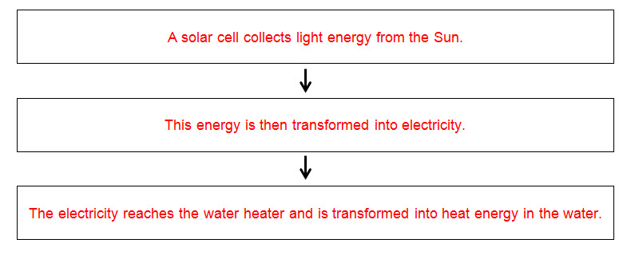

3 What are some of the many benefits of using solar panels?

Answers will vary, but could include that we get sunlight every day for free and this can be used to power a range of things in place of burning fossil fuels, which are limited resources.

4 What inventions and new productions can you think of that might use solar power?

Answers will vary, but could include solar vehicles (such as cars, skateboards, jet packs), solar roads and solar planes.

5 What is it about Australia specifically that makes it so well suited to solar power?

Australia has a lot of uninhabited land and plenty of sunlight.

6 What percentage of the world does not have access to electricity? How many people does that amount to?

Around 20% of the world’s population does not have access to electricity. This equates to around 1.4 billion people.

7 Describe some ways that not having electricity would affect your life.

Answers will vary, but could include not having access to technology and entertainment, limited communication methods, lack of electrical machinery resulting in more manual labour, lack of medical technology potentially meaning poorer health.